**STAT 40001/ STAT 50001 Statistical Computing Fall 2023**

**Lab-1**

Calculate the following

1. 47+8-13×56+78
2. 46-87+98-57
3. 46-87+98-57
4. 4+(35mod 6)+9 ln(5)
5. 67÷5+9×37
6. |-7|+|5|+log(10)
7. 7+log(5)+75+45
8. 
9. 

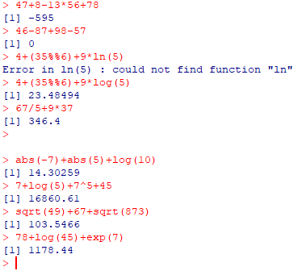

We have several way of rounding the numbers including

ceiling takes a single numeric argument x and returns a numeric vector containing the smallest integers not less than the corresponding elements of x.

floor takes a single numeric argument x and returns a numeric vector containing the largest integers not greater than the corresponding elements of x.

trunc takes a single numeric argument x and returns a numeric vector containing the integers formed by truncating the values in x toward 0.

round rounds the values in its first argument to the specified number of decimal places (default 0).

signif rounds the values in its first argument to the specified number of significant digits.

zapsmall determines a digits argument dr for calling round(x, digits = dr) such that values “close to zero” (compared with the maximal absolute value) are “zapped”, i.e., treated as 0.

Given two numbers 1.023456, 5.45768, and 1.678927 use the following options



1. round

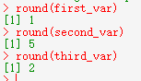

1. ceiling

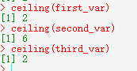

1. floor

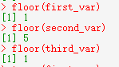

1. trunc

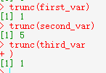

1. signif

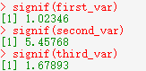

1. zapsmall

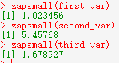

1. Sort the data in decreasing order:

3, 5, 7, 2, 9, 12, 45, 23, 31, 45, 7, 82, 90, 5

1. Sort the data in increasing order

4,6,7,8,2,3,6,8,4,9,15,34,23,81,-5,-9

